

|  |
| --- |
|  |
| Grizzly InternNET |
| Spring 2022  ITEC 4860 |



**Table of Contents**

Website Banner & Logo 5

Banner 5

Logo 5

Group Members 6

Ruby Hernandez 6

Ryan Gambrell 6

John Brandt 7

Nicholas Porter 7

About 8

Summary 8

Deployment 8

Completed User Stories (Features Implemented) 9

US001 – US031 9-12

Potential Features To Be Implemented 13

Forum Post Comments 13

User-To-User Chat Messenger 13

Resume/CV Document Previews 13

Enhanced Search Bar 13

Installation and User Documentation 14

GitHub Repository 14

JIRA Board 14

Firebase Account 14

# Website Banner & Logo

|  |
| --- |
| **Banner** |

|  |
| --- |
| **Logo** |

# Group Members

## **Ruby Hernandez**



Contact Email

hernandezruby2000@gmail.com

## **Ryan Gambrell**



Contact Email

ryanpeytongambrell@gmail.com

## **John Brandt**



Contact Email

jchristianbrandt53@gmail.com

## **Nicholas Porter**



Contact Email

nickporter916@gmail.com

# About

|  |
| --- |
| **Summary** Grizzly InternNET is a review website that allows Georgia Gwinnett College students to assign ratings to any previous internships or entry-level jobs related to their degrees. The idea for Grizzly InternNET was founded by Ruby Hernandez, and developed in collaboration with her group members Ryan Gambrell, John Brandt, and Nicholas Porter. **Deployment** The online platform currently remains in development, and is expected to be deployed and released in 2023. Grizzly InternNET is intended to be used by students across all majors and concentrations at Georgia Gwinnett College. |

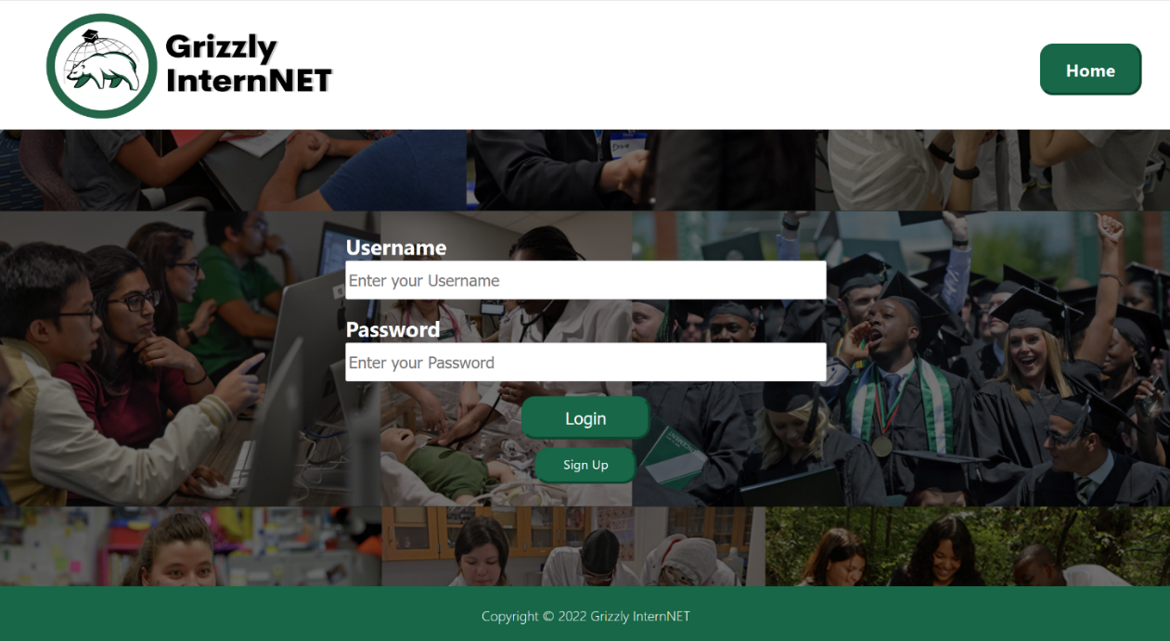

*Figure 1: Screenshot of Grizzly InternNET Landing Page*

|  |
| --- |
| Completed User Stories (Features Implemented)**US001** As a User, I can log in/sign up on the website with an email (@ggc.edu) address and password, so that I can access my personal profile. **US002** As a User, I can log out of my own account, so that I can no longer access my personal profile. **US003** As a User, I can edit my own account by adding my name to my profile, so that other users can view my name. **US004** As a User, I can edit my own account by adding a profile photo to my profile, so that other users can view my image. **US005** As a User, I can edit my own account by attaching my Resume/CV to my profile, so that other users can view my qualifications. **US006** As a User, I can edit my own account by selecting my major/concentration from a drop-down list, so that other users can view my major/concentration. **US007** As a User, I can view the profiles of other users, so that I can view their information. **US008** As a User, I can create a forum post, so that I can write up a description that explains and details my experience. **US009** As a User, I can edit my previously written forum posts, so that I can make any changes as needed. **US010** As a User, I can delete my previously written forum posts, so that I can delete any unwanted posts. **US011** As a User, I can specify my name on my forum post, so that other users know my name. **US012** As a User, I can specify the company name on my forum post, so that other users know where my experience took place. **US013** As a User, I can add a company logo to my forum post, so that other users can view the logo of the business where my experience took place. **US014** As a User, I can specify the job title in my forum post, so that other users know what my position at work was. **US015** As a User, I can specify the start and end dates of my job on my forum post, so that others can see how long I spent at that job. **US016** As a User, I can choose 3 out of 10 characteristics on my forum post, so that I can show which attributes best described my experience. **US017** As a User, I can select whether my job was paid, unpaid, stipend-based, or N/A on my forum post from a drop-down menu, so that other users can view that information. **US018** As a User, I can detail what my work schedule looked like during my experience, so that other users can view that information. **US019** As a User, I can rate my experience out of 5 stars, so that other users can view my rating. **US020** As a User, I can view the forum posts of other users, so that I can learn about their experiences. **US021** As a User, I can search for forum posts by company name, so that I can filter out and view specific experiences. **US022** As a User, I can search for forum posts by major/concentration, so that I can filter out and view specific experiences. **US023** As a User, I can up-vote other users’ forum posts, so that I can boost the viewability of specific posts. **US024** As a User, I can sort posts by up-votes (most to least), so that I can better view forum posts to my liking. **US025** As a User, I can sort posts by up-votes (least to most), so that I can better view forum posts to my liking. **US026** As a User, I can sort posts by company name in alphabetical order (A-Z), so that I can better view forum posts to my liking. **US027** As a User, I can sort posts by company name in alphabetical order (A-Z), so that I can better view forum posts to my liking. **US028** As a User, I can sort posts in chronological order (newest to oldest), so that I can better view forum posts to my liking. **US029** As a User, I can sort posts in reverse chronological order (oldest to newest), so that I can better view forum posts to my liking. **US030** As an Admin, I can delete the posts of other users, so that I can delete any spam or unwanted forum posts. **US031** As an Admin, I can delete the profiles of other users, so that I can delete any spam or unwanted profiles. |

# Potential Features To Be Implemented

|  |
| --- |
| **Forum Post Comments** Giving users the ability to comment on one another’s posts would be a great way to encourage forum discussion between website users. **User-To-User Chat Messenger** Implementing a chat messenger would allow students to connect with students and potentially ask them for advice in regards to specific internships. **Resume/CV Document Previews** Adding an automatic document previewer on each user’s profile page would help users avoid from having to download every single Resume/CV that they want to take a quick look at. **Enhanced Search Bar** Giving users more way to search (specific user profiles, forum post keywords, etc.) would help them better find what they’re looking for. |

# Installation and User Documentation

|  |
| --- |
| **GitHub Repository** <https://github.com/rwprice31/InternNet> **JIRA Board** <https://jira.ggc.edu/projects/INN/summary> **Firebase Account** Please contact Ryan Gambrell ([ryanpeytongambrell@gmail.com](mailto:ryanpeytongambrell@gmail.com)) for this information. |